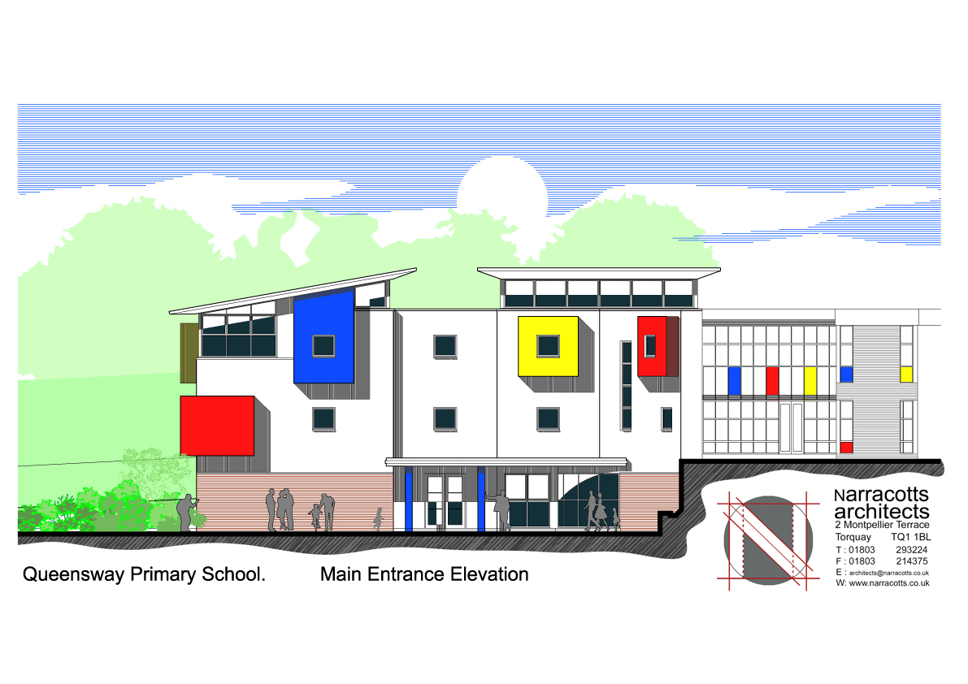


OUR LADY OF THE ANGELS

CATHOLIC PRIMARY SCHOOL
QUEENSWAY
CHELSTON
TORQUAY TQ2 6DB

Tel: 01803 613095
e-mail admin@queenswayprimary.co.uk
www.queensway-primary.torbay.sch.uk

4th December 2017

Dear Parents,

We are fortunate next term to be able to offer some extra after school sports clubs free of charge. Places are limited. If your child wishes to attend a club, please complete the slip below and return it to the office by Friday 15th December.

These clubs will begin the week beginning 8th January.

CLUB | DAY / TIME | FACILITATOR | KIT
Fencing/Archery  FS/KS1 only | Thursday  3.15 – 4.15 | Premier Sports  10 sessions 11/1/18 -22/3/18 | P.E. kit
Handball  All ages | Friday  3.15 – 4.15 | TUFITC | P.E. kit

Please note that the football club on a Tuesday will continue as previously.

We will confirm, via text message, if your child has a place.

If an after school club is to be cancelled, possibly due to the weather or staff illness, you will be notified by text message as soon as possible.

OUR LADY OF THE ANGELS CATHOLIC PRIMARY SCHOOL, QUEENSWAY

Name of child.............................................................................Class............................

□ I would like my child to attend fencing/archery club.

□ I would like my child to attend handball club.

Emergency contact number..............................................................................

Signed .....................................................................Date....................................






