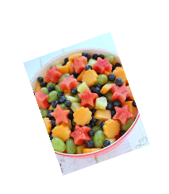
Instructions : How to make a….
This set of instructions was written by Pie Corbett.
He is a writer, author and poet.
He teaches teachers how to teach writing!

Expanded Noun Phrases
Verbs | A doing or being word  Eg: cutting, slicing, mixing
Imperative Verbs | Known as bossy verbs – they tell you what to do. They turn a sentence into a command. Eg : Fold your clothes up.
How adverbs | Words that describe the action.  Eg: whisk the eggs carefully.
Headings | Tells the reader what the page is about.
Subheading | Tells the reader what information they will find in the next paragraph.
Bullet points | Are used for making lists.
Chronological order | The order of events in the correct time in which they happen.
Other information
Instructions are a step by step guide that explains how to make or do something. An instruction can be written or spoken.
Key Vocabulary | Definition
alternative | A different possibility or choice.
satisfy | To be happy with or pleased with.
flourish of flavours | Many bold or strong flavours.
Equipment | Items needed to complete the task.
Ingredients | Food items needed to make the recipe.
Method | The particular actions needed to complete the recipe.

