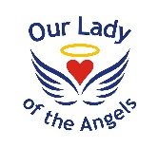
Blue John – Berlie Doherty
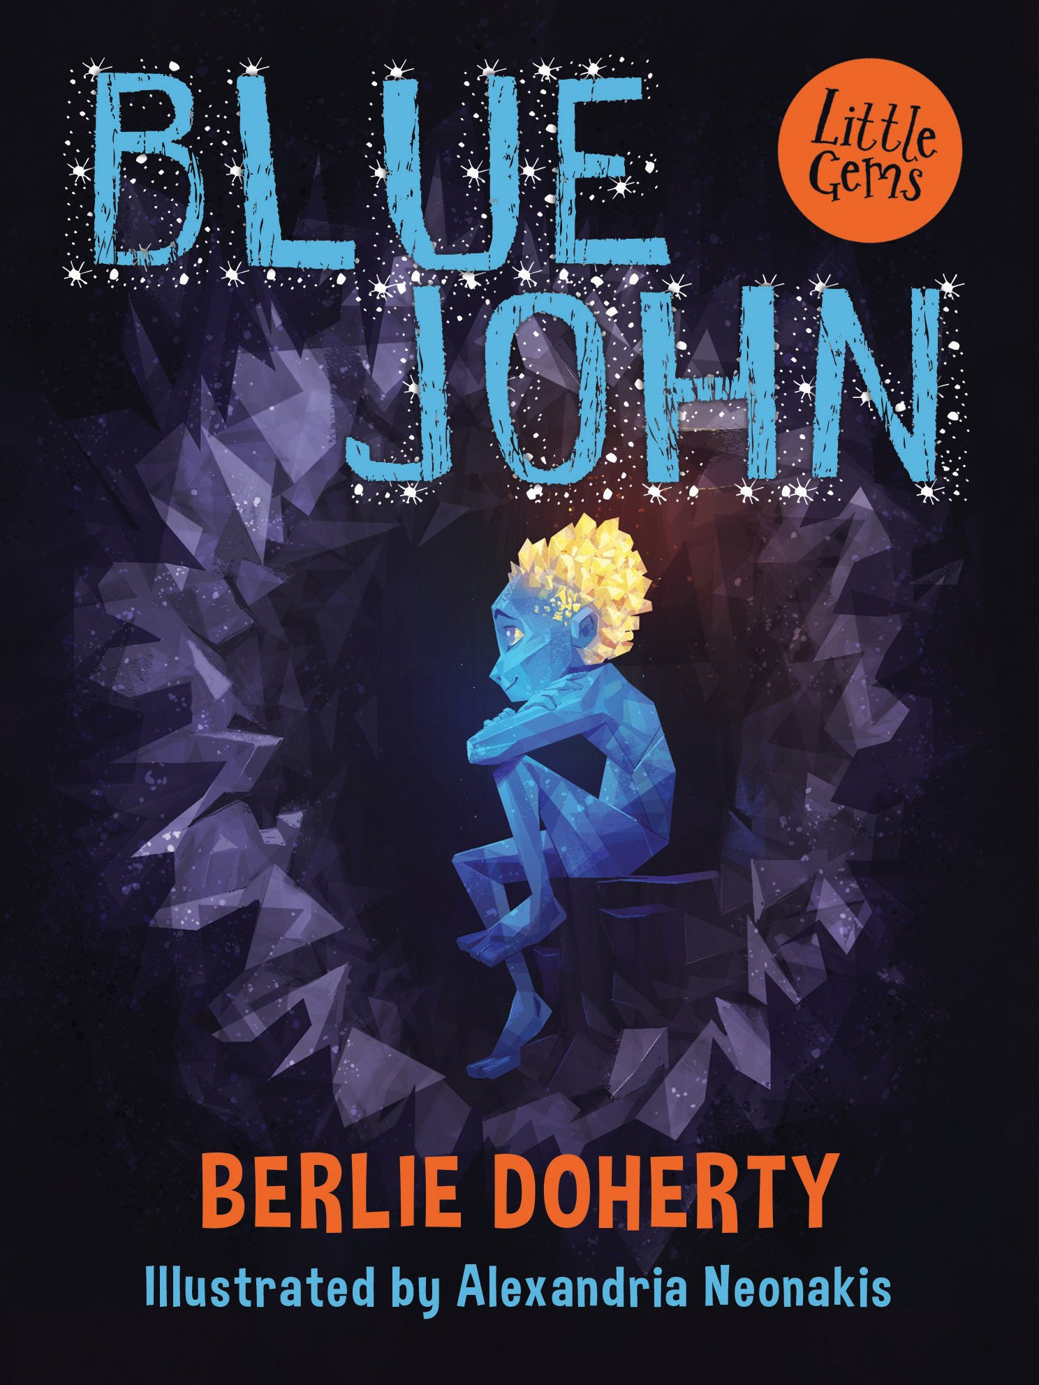

Berlie Doherty was inspired by music and landscape to create her story, in which the Queen of Darkness makes a child for herself in her deep, dark cave below Mam Tor. To make her child she fuses together the yellow light of the sun and the blue heart of a glacier. Blue John is born, but he must forever live in darkness. When he is tempted out into the light of day by the laughter and singing of children, he is turned to stone – the beautiful blue and yellow crystal for which Derbyshire is famous across the world.

Other information
The caverns of Castleton are famous for being the only place in Europe, some say in the world, where a fluorite crystal known as Blue John is found. It was first discovered by French miners extracting lead from the caverns, and they called it bleu-jaune because of its colour. Now it’s known everywhere as Blue John. It is a beautiful semi-precious mineral, and has been made into wine glasses, jewellery and other ornaments.
Figurative language
Conjunctions | A word that joins words, phrases, clauses or a sentence. e.g. but, and, yet, or, because, nor, although, since, unless, while, where etc.
Adverbs | A word that describes a verb (he sings loudly), an adjective (very tall) or another adverb (ended too quickly). Adverbs often end in -ly (softly).
Prepositions | A word that tells you where or when something is compared to something else, e.g. after, before, on, under, inside and outside.
Direct speech | A sentence in which the exact words spoken are in speech marks/inverted commas, e.g. "You'll never guess what I've just seen!" said Sam.
Paragraphs | A paragraph is a section of writing consisting of one or more sentences grouped together and discussing one main subject.
Key Vocabulary | Definition
glacier | A large area of thick ice that remains frozen from one year to the next. Glaciers also slowly flow over the land.
chamber | A private room / enclosed space.
enchantment | To be put under a spell.
stalactite | An icicle shaped formation hanging from the roof or side of a cave.
amethyst | A purple coloured crystal.
amber | A yellowish orange colour.
curlew | A large brown bird with long legs and a long curved beak.
awe | A feeling of wonder and admiration.
grief | A strong feeling of sadness when someone dies.
ebony | A very dark black colour.

