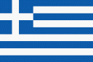
GREECE
KNOWLEDGE ORGANISER
Overview |  |  | Human Geography |  |  |  | Key Vocabulary  Greece  Europe  Mediterranean  Athens  Ancient  Crete  Aegean Sea  Ionian Sea  Mt. Olympus  euro  tourism  volcanoes  islands  mountains  seafaring  coastline  climate
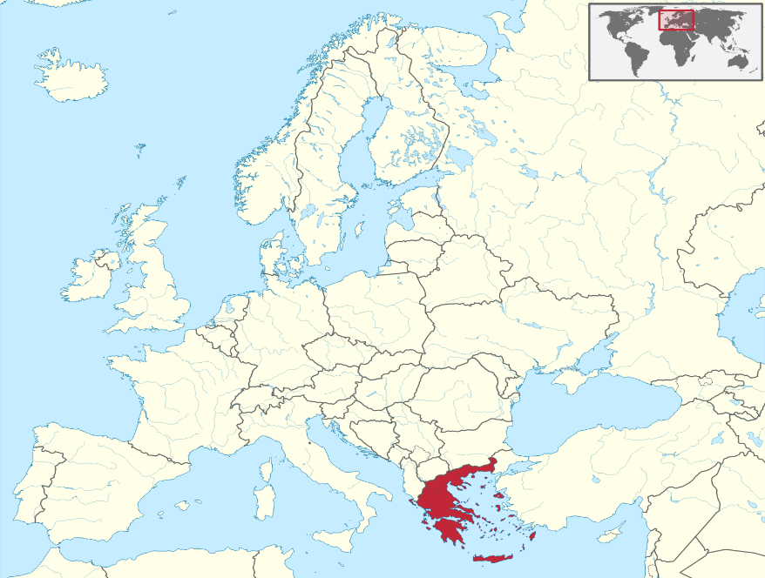  -Greece is a country in south-eastern Europe.  -It borders a number of countries, including Albania, Turkey, Bulgaria and Macedonia.  -It also has a large coastline on the Mediterranean Sea.  -Greece covers an area of 131,957 sq. km. It is the 15th largest European country by area.  -About 10.8 million people live in Greece. The capital city is Athens.  -Greece has around 6,000 islands, although only around 227 of these are habited. |  |  | Greece has a long and rich history, and a culture which has developed over thousands of years from the time of the Ancient Greeks. Its warm climate also makes it a popular holiday destination for people from across the world.
 |  |  | Population | 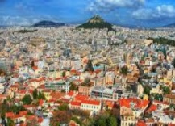 | The population of Greece is around 10.8 million people. This makes it the fourteenth most populous country in Europe. The population density is 82 people per square kilometre.
 |  |  | Settlements | 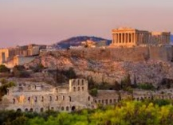 | The most populous and capital city of Greece is Athens. It has a population of over 3 million people. Other large settlements include Thessaloniki, Patra, Piraeus and Larisa. Most settlements were founded around the coast, as Greeks historically were seafaring people.
 |  |  | Economic Activity | 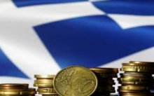 | -Greece is a part of the European Union and its currency is the Euro. Greece has suffered many financial problems in recent years, and have had to be helped by other countries. Tourism is a large source of income for Greece.
 |  |  | Resources/ Trade | 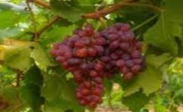 | Greece have many natural resources, and are a large trader of petroleum products. In terms of food, Greece exports high quantities of fresh fish, olive oil, tomato-based products and wine.
Physical Geography
-Greece is one of the most mountainous countries in Europe. The northern mainland region is the most mountainous. The highest peak is Mt Olympus, which is 2,917m high.  -Greece also contains thousands of islands in the Aegan, Ionian and Mediterranean Seas. The largest island is Crete.  -Greece has a warm and sunny climate. The temperature averages around 33°C in summer and 14°C in winter. Rainfall is heaviest in the northern mountains. Some islands receive very little yearly rain.  -There are many volcanoes. The most famous are those of Santorini, Kos, Milos and Nisyros.  -Lakes of a large size include Trichonis, Vegoritis and Volvi. | 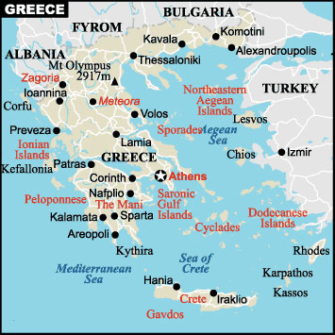 |  | Comparison with the UK
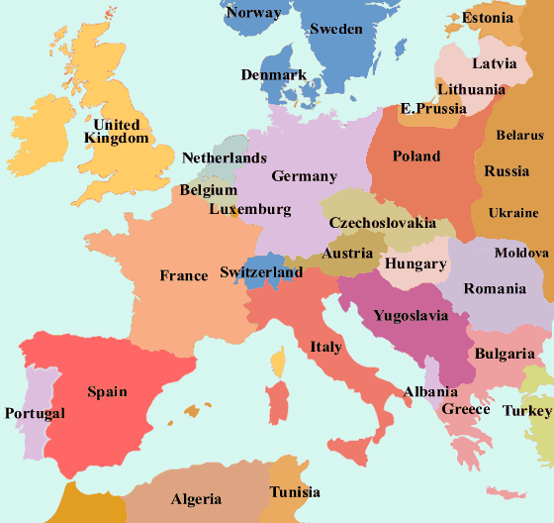
-Both countries are in Europe: the UK is in northern Europe & Greece in southern Europe.
Greece is warmer than the UK. On average, Athens is 9°C hotter than London.
-Greece is smaller than the UK – 131,957 sq. km compared to 243,610sq km.
-Significantly more people live in the UK – 66 million compared to 10.8 million. London has a much larger population than Athens: 8.4 million compared to 3.1 million.
-Greece has higher mountains than the UK. Mt. Olympus is 2.917m high. The highest in the UK is Ben Nevis, at 1,345m.
-Greece is made up of many more islands than the UK. It has a much longer coastline.

