Dear Parents and Carers

Year 3 Residential

I am pleased to tell you that we have booked a Year 3 residential trip to Warren Barn for Wednesday 24 - Friday 26 April. The trip offers an enjoyable and intensely exciting learning experience as well as the opportunity to develop each child’s independence and self-organisational skills. We do hope that your child will be able to join us.

We have done our best to keep the cost of the trip as low as possible at £86.00. This includes 2 nights accommodation, meals (children will need to bring a packed lunch on the first day and all activities. Please see the itinerary below. The children will be accompanied by at least four school staff members.

Wednesday | Thursday | Friday
Parents drop off from 9am - 9.30am* | Breakfast (Cereal and toast) | Breakfast (Cereal and toast)
Unpack and familiarise | Walk to Occombe Farm | Pack and tidy up rooms
Sketches in nature (Darwin style) | Organic Pizza Making with home grown herbs | Introduction to firecraft
Eat own packed lunch from home | Packed lunch (provided) | Packed lunch (provided)
Team Challenges | Meet farm animals and visit bird hide | Natural Den building
Pasta Bolognese from the Occombe Farm cafe | Chicken Casserole and Rice from Occombe Farm cafe | Parents pick up from 3.30 - 3.50pm*
Night nature walk during sunset | Movie/Talent night
Journal writing | Journal writing
Hot chocolate before bed | Hot chocolate before bed

*Please note that the lane to Warren Barn is very narrow and there is no parking therefore drop off and pick up needs to be staggered.

The children will sleep in Warren Barn - a former farm building. The school has exclusive use of the facility. There are separate dormitories for girls and boys. An information session to answer any queries you may have about the trip will be held after school on Friday 15 March in Y3. If you have any questions but are unable to attend the session, please request a phone call via Mrs Gale in the office or speak to Mrs Griggs directly.

We are required to confirm numbers by Friday 29th March therefore all payments must be made in full by that date. Payments can be made by cheque (made payable to Plymouth CAST) or cash and in installments. These should be sent in to school in a sealed envelope clearly marked ‘Warren Barn Y3’ with your child’s name. A payment card will be provided to assist you in keeping track of how much you have paid.

The school will fund the complete cost of the trip for any children that are currently in receipt of Free School Meals but the attached form must be completed and returned by 15 March to secure a place.

Payment must be made in full by Friday 29 March 2019. If payment is not made in full by this date, your child will not be able to attend. If subsequently the school is charged by the provider for your child’s place due to late cancellation, payments made to the school by this date will be lost, and you may still be liable for further payments. We do not wish children to miss out due to financial constraints so if this is a concern to you, please make an appointment to speak to Mrs Harding in confidence.

We look forward to a highly memorable time together.
With best wishes

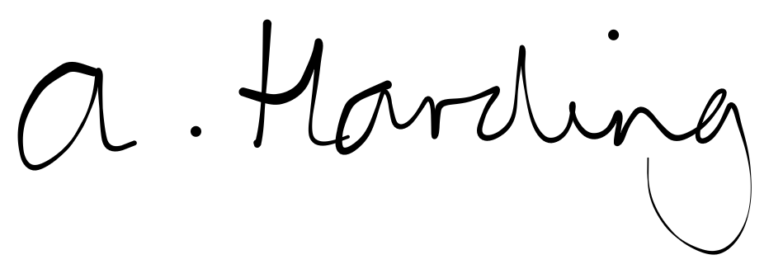

Mrs Harding
Headteacher
Please return to the school office by Friday 15 March Y3 Warren Barn 2019

Child’s name: ________________________________________________________________

I wish to reserve a place for my child on the trip. ◻ Yes ◻ No

My child is currently in receipt of free school meals. ◻ Yes ◻ No

Please list any dietary needs or allergies that your child has (e.g vegetarian, food intolerances):

Please list any medication (apart from Calpol – see below) and the dosage that your child will or may need:

Please list any medical needs or issues (e.g bed wetting / sleep walking) that we should be aware of:

Is there any other information that we should know about your child?

Please include the name and address of your child’s doctor and surgery.

Please turn over.

I do/do not* give permission for my child to be administered Calpol should the lead teacher feel it appropriate.

I give permission for my child to be administered first aid in the event of an emergency.

Parent’s Names: ____________________________________________________________

Parent’s Signature: _____________________ Home number: ________________________

Mobile number 1:_______________________ Mobile number 2:_______________________

