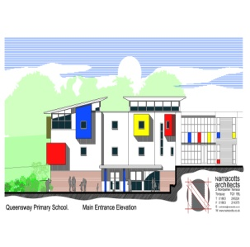
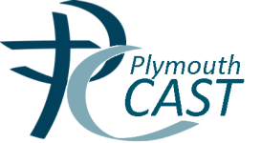
OUR LADY OF THE ANGELS

CATHOLIC PRIMARY SCHOOL
QUEENSWAY
CHELSTON
TORQUAY TQ2 6DB

Tel: 01803 613095

e-mail admin@queenswayprimary.co.uk
www.ourladyoftheangels.eschools.co.uk

Self-Declaration form

Pupil‘s name ...................................................................................................

Parent/Guardian’s name .................................................................................

Address ............................................................................................................

Contact number ................................................................................................

Self-declaration

I attend the church of ...................................................................................................

I confirm that my child is baptised
(Category 2) Yes / No
I confirm that my child is enrolled on a programme for Baptism
(Category 4) Yes / No
I confirm that I am baptised in the Catholic Church
(Category 5) Yes / No
I confirm that my child is a member of another recognised Christian Faith
(Category 6) Yes / No
I confirm that my child is a member of another recognised faith tradition
(Category 7) Yes / No
I confirm that I wish my child to experience a faith centred education
(Category 8) Yes / No

Signed ................................................................

For categories 2-6 please pass the whole form to your Parish Priest or Minister for completion. This should then be returned to the school.
For categories 7 and 8 please return the form directly to the school.

Priest’s / Minister’s Confirmation

I am able to agree with the statement above Yes / No

I am unable to agree with the statement Yes / No

Signed ............................................................................

Please annotate as appropriate and apply a church stamp

