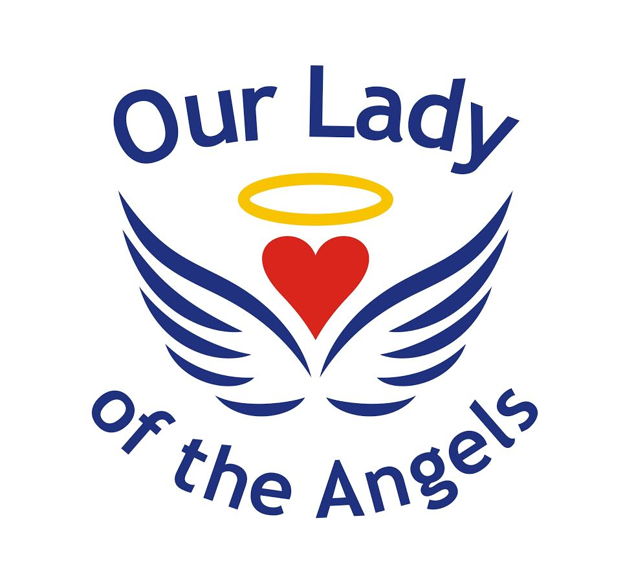

Early Years Foundation Stage Policy

Last Update: September 2019
Version: 1.0

Document Control
Changes History

Version | Date | Amended by | Recipients | Purpose

Approvals

This policy/procedures requires the following approvals:

Governors | HT | Date Approved | Version | Date for Review
 | ✓ | September 2019 | 1.0 | July 2021

National/Local Policy

This policy is local to Our Lady of the Angels Catholic Primary School.

Position with the Unions

Does the policy require consultation with the National Unions under the recognition agreement? Yes/No

Distribution

This document has been distributed to:

Position | Date | Version
All OLOTA employees |  | 1.0

The overall aim of this policy is;
- to ensure consistency in teaching and learning throughout the Early Years Foundation Stage.

Definition

The Early Years Foundation Stage is a very important stage as it prepares a child for school as well as preparing them for their future learning and successes. From when a child is born up until the age of 5, their early years experience should be happy, active, exciting, fun and secure; and support their development, care and learning needs.

Principles of the Early Years Foundation Stage

- Every child is a unique child who is constantly learning and can be resilient, capable, confident and self-assured;
- Children learn to be strong and independent through positive relationships;
- Children learn and develop well in enabling environments, in which their experiences respond to their individual needs and there is a strong partnership between practitioners and parents and/or carers; and
- Children develop and learn in different ways and at different rates. The framework covers the education and care of all children in early years provision, including children with special educational needs and disabilities.

Principles into practice
As part of our practice we:
- Provide a balanced curriculum, based on the EYFS, across the seven areas of learning, using play as the vehicle for learning
- Promote equality of opportunity and anti-discriminatory practice. We provide early intervention for those children who require additional support
- Work in partnership with parents and within the wider context
- Plan challenging learning experiences, based on the individual child, informed by observation and assessment
- Provide opportunities for children to engage in activities that are adult-led and child-initiated, supported by the adult
- Have a key person approach to develop close relationships with individual children
- Provide a secure and safe learning environment indoors and out

The Foundation Stage Curriculum

The Early Years Foundation Stage curriculum is organised into seven areas of learning and development.

Children should mostly develop the 3 prime areas first. These are:
- Communication and language;
- Physical development; and
- Personal, social and emotional development.
These prime areas are those most essential for your child’s healthy development and future learning.

As children grow, the prime areas will help them to develop skills in 4 specific areas. These are:
- Literacy;
- Mathematics;
- Understanding the world; and
- Expressive arts and design.
These 7 areas are used to plan a child’s learning and activities. The professionals teaching and supporting will make sure that the activities are suited to each child’s unique needs and it is flexible.
Children in the EYFS learn by playing and exploring, being active, and through creative and critical thinking which takes place both indoors and outside.
Religious Education
As Catholic schools, in addition to the above 7 curriculum areas, we dedicate 10% of our time to Religious Education.

Assessment in the Early Years Foundation Stage

Expected levels that a child should reach at age 5, usually the end of the reception year; are called the Early Learning Goals (ELGs). At the end of the EYFS – in the summer term of the reception year in school – teachers complete an assessment which is known as the EYFS Profile. This assessment is carried out by the reception teacher and is based on what they, and other staff, have observed over a period of time.
Staff partake in ongoing assessments of the children on a daily basis. All staff observe the children during adult-led and child-initiated activities and all of the information collected is used to judge how a child is progressing in the 7 areas of learning and development. The information gathered is then used to inform teachers’ judgements of individuals against the Development Matters objectives for each of the 7 areas.

Role of Parents and Carers
We strive to create and maintain strong partnerships with parents and carers as we recognise that together, we can have a significant impact on a child’s learning. We welcome and actively encourage parents to participate confidently in their child’s education and care in numerous ways.

