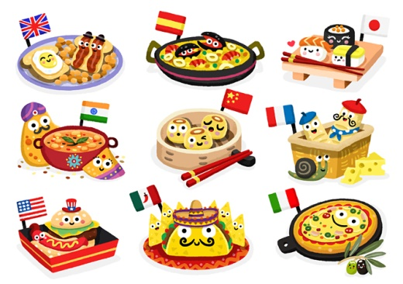

Homework

See the attached sheet. Think carefully about your presentation as we would like to display your work. Homework is due on the 15th February 2019.

Geography

We will be looking at various maps of the world. We will be learning about continents and countries, including discussing the country’s culture and most commonly found ingredients. We will also discuss the climate of the country and how this relates to the most commonly eaten food.

Discrete learning

RE, PE, Handwriting, Computing, SPAG (Spelling, Punctuation and Grammar)

French

As well as learning some basic French vocabulary, we will spend some time learning about the food culture in France and French vocabulary for basic foods.

Maths

We will be using our Maths skills to help us read scales accurately and understand about converting measurements. This will be vital to ensure we make our food correctly following given instructions.

There will be other discrete Maths learning taking place focusing on place value, as well as addition and subtraction.

English

Y3 will be learning the skill of instructional writing and aim to produce a set of instructions about how to kill a wolf based on the book ‘The three little pigs’ The children will be thinking about how they can include more detail in their writing, ensuring it is still clear and concise! They will be thinking about the effect their writing and language has on the reader. We will also look at the book Grow your own Lettuce. Y4 will write a Non-Chronological report with a focus on bananas, then moving onto writing about a food of their choice. Performance Poetry and Persuasive Writing.

Science

We will look at food groups, thinking specifically about the need for the right types and amount of nutrition.

Y3 will also study Animals including Humans

Y4 will also study Electricity and States of Matter

DT

The children will be cooking lots, they will have the opportunity to make delicious food and sweet treats. We will talk about how to make sure the food we eat is prepared safely and hygienically as well as ensuring it tastes delicious.

Food, glorious food!

Learning Experience Year 3&4

Monday 7th January 2019 - 5th April 2019