Governorlink

Helping Parents Understand Governance

OLOTA CATHOLIC PRIMARY SCHOOL IS AN ACADEMY WITHIN PLYMOUTH CAST. WHAT DOES THIS MEAN?

Plymouth CAST was established by the Diocese of Plymouth as a charity and limited company. Queensway Catholic Primary School is an academy within CAST (Catholic and Anglican Schools Trust), working in solidarity for the common good. The Diocese retains ownership of the buildings but the Local Governing Body is responsible for maintaining the buildings and facilities. CAST receives our funding from EFA which they distribute for staff and running costs and we decide how that funding is to be best spent – the principle of subsidiarity. While Plymouth CAST is now the employer of the staff, the Local Governing Body remains responsible for staff recruitment, drawing up an admissions policy and deciding which children should be admitted to the school.

WHAT DOES THE LOCAL GOVERNING BODY DO?

Every school has a Governing Body and, as an academy within Plymouth CAST, the Local Governing Body retains many of the duties it fulfilled when the school was voluntary aided. The Local Governing Body consists of representatives from the local community including parents, the parishes and school employees. Governors do not need any specific qualifications and are welcome from all walks of life.

Under the Scheme of Delegation the Board of Directors of Plymouth CAST have delegated responsibility for ensuring good governance to The Local Governing Body, which will be the Advisory Body for Queensway Catholic Primary School. The Local Governing Body appoints the Head Teacher, as a professional, to manage the school and staff on a day to day basis. The Head Teacher, Staff and Governors work together to run all aspects of school life. The Local Governing Body has to monitor and evaluate progress towards the school’s priorities and targets, support the Head Teacher and staff as well as challenging their expectations, and account to all stakeholders for the school’s overall performance and for the decisions they have made. They do not run the school day to day.
This is a fulfilling and rewarding experience for governors, who are all unpaid volunteers. Employers are legally bound to allow employees reasonable release time, with pay, to fulfil governor responsibilities.

THE GOVERNOR TEAM

Father John Smethurst – Foundation Governor
Mrs. Angie Baldwin - Foundation Governor
Mrs. Judith Davies - Foundation Governor
Mrs. Juliette Edwards - Foundation Governor
Councillor Nicole Amil – Foundation Governor
Ms. Lisa Southwell– Foundation Governor
Mrs. Fiona Tookey – Foundation Governor
Mr. Stephen Corline – Parent Governor
Mrs. Julie Kennard – Teacher Staff Governor
Mrs. Teressa Lewis – Support Staff Governor

Mrs. Jane Fraser - Interim Head Teacher, ex officio Governor

TYPES OF GOVERNORS

At Our Lady of the Angels we have.........
7 Foundation Governors
2 Staff Governors – a Staff governor and a Support Staff governor
1 Parent Governor
The Head Teacher is a ex officio governor, a governor due to their position in the school

We can appoint community governors, co-opt governors and increase parent governor representation as long as Foundation Governors are in the majority by two.

You can find out more by reading the sections below.

HOW CAN I CONTACT A GOVERNOR?

You will find governors at school events such as
- Parent/teacher consultations
- Queensway Association fundraising events
- School Productions

Governors love to chat! Come and introduce yourself.
We always welcome new suggestions.... why not email us at queenswaygovernors@gmail.com - your ideas will be shared at Governors’ meetings. Don’t just talk about a good idea to your friends – tell us!

However, if you wish to contact the Chair of the Local Governing Body directly, please contact the Clerk.

Father John Smethurst
Foundation Governor

I was ordained priest on 30th June in 1999 after 30 years in Anglican ministry. My first appointment in Torquay was in 1976 when I became chaplain and lecturer at South Devon Technical College (then situated in Torre). When I left the Church of England, where I had a parish in Plymouth, I returned to Torquay. Following ordination I served at Sacred Heart Church in Paignton for 10 years, though for the last three of these years I was linked also to Holy Angels, finally becoming Parish Priest in 2009. The priests from Abbey Rd and Chelston are chaplains to our school. When Fr Brian Kenwrick left Torquay, I replaced him as a school governor.

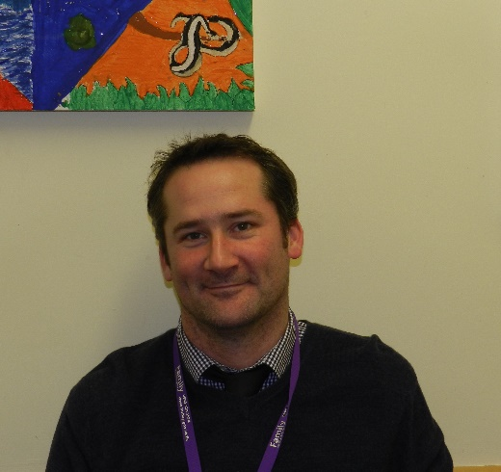
Mr. Stephen Corline
Parent Governor

I have two daughters at the school and was elected Parent Governor in October 2013. I have lived in Torquay for most of my life and enjoy playing and watching sport when not working.

Since becoming a governor I have enjoyed seeing how the different aspects of the school are run and managed and how much thought and debate go into making all the decisions that affect all of the children who attend the school.

I hope to support the school in doing the best it can for all the children who come through its doors as well as being the link between parents and the school. I can be contacted at stephen.corline@sky.com

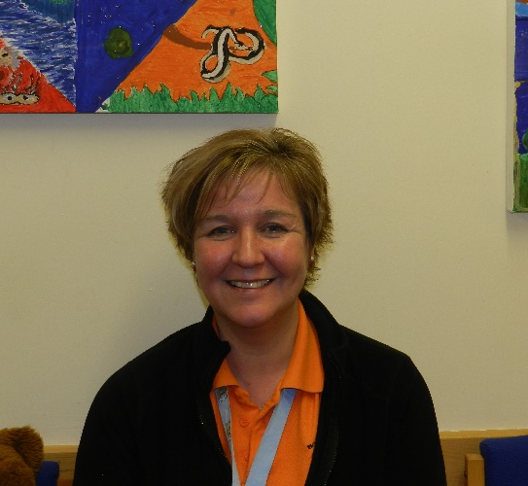
Mrs. Angie Baldwin
Foundation Governor

I grew up in Manchester and I’m an avid Manchester City fan, having had a season ticket at Maine Road during my teenage years.

My husband and I moved down to Torquay in 1985. Our eldest son started at Queensway in 1993, and my daughter in 1994. I became a Governor at Queensway School in 2003, when our youngest, twin boys, were in
year 5. My husband and our children are all Manchester United fans, which makes for interesting derby days!!

I have been Manager of Holy Angels Pre-school since 1994, during that time we have been very lucky to have enjoyed close links with Queensway. The many years I have been a Governor have flown incredibly fast, I didn’t expect to enjoy the role of Governor as much as I do.
Being a governor can be challenging, we have to ensure we are up to date with policies, guidelines and statutory requirements; we have to make decisions, sometimes fairly difficult ones, and we may not always agree. However, it’s also very interesting, and it is lovely to work with a group of people who have the same aim in mind, who meet for the good of Queensway School. Queensway is a lovely caring family based school, and I feel quite privileged to have a role within it.

I can be contacted at holyangels@blueyonder.co.uk

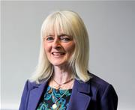
Councillor Nicole Amil
Foundation Governor

I am the current Ward Councillor for Cockington with Chelston and the Mayor’s executive lead for Tourism, Culture and Harbours. I joined Queensway Primary School as a Local Authority Governor in 2011 and when the school changed status in 2014, I was invited to become a Foundation Governor.

I enjoy working with the other Governors and want to continue to keep the School progressing to provide the best education possible for its young students. I take a
keen interest in issues affecting local residents and am heavily involved in projects within the local community.

I am an active member of the Community Partnership and support local churches, schools and as many charitable organisation as my time allows. I am fully committed to Queensway School and look forward to helping the school flourish in the years ahead.

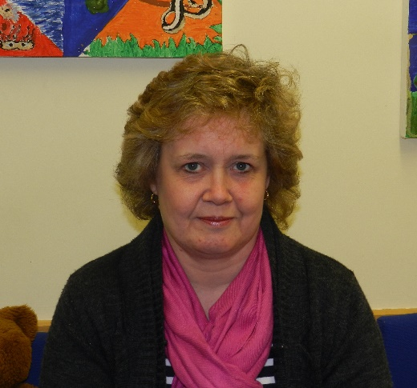
Mrs. Judith Davies
Foundation Governor

I joined the Governing Body in 2004 when the youngest of my three children started school. I was initially a Parent Governor and after my term of four years was invited to become a Foundation Governor.

Whilst working at Holy Angels Pre-School, it has been great to see the relationship with Queensway develop. After much planning, we were so fortunate
to be included within the wonderful new building that we all now enjoy, when we moved on site at Easter 2011.

Being a governor is both challenging and rewarding, with each member bringing their own knowledge, experience and particular expertise to meetings. I appreciate the opportunity to work in a team that strives towards the same vision

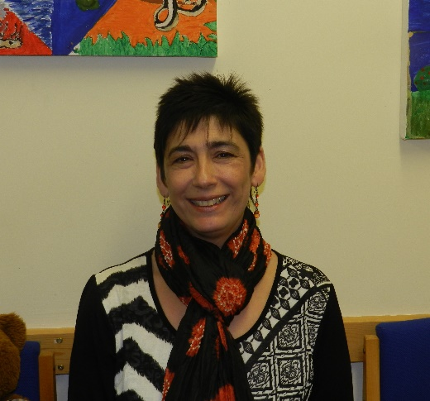
Juliette Edwards
Foundation Governor

I have had children at Queensway Primary School since 2001 when we moved back to Torquay. My experience of the school has always been a positive one and when I was invited to be a foundation governor I took it as an opportunity to give something back and to gain personal experience of how a primary school is run. The Catholic Church has been an important part of my life since 1995, and I am a firm supporter of Catholic Primary education.

I have had a big career break until recently to bring up our family of 4 children, during which time I qualified as a CBT counsellor. I have worked voluntarily as a counsellor for a local charity since 2008 with young people from the age of 11. I also work part time as a teaching assistant in a local primary school.

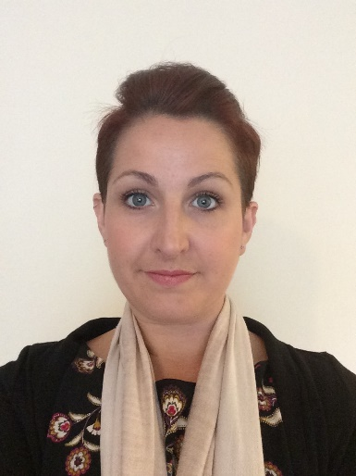
Ms. Lisa Southwell
Foundation Governor
My eldest child started at Queensway Catholic Primary School in 2013 and I became a Foundation Governor in 2015, just as my second child was due to also start at Queensway.
After working in the field of learning difficulties and autism for several years, I decided to retrain as a Complementary Therapist in 2011 and become self-employed so I could better meet the needs of my family. Then after the birth of my third child in 2013, I chose to give up work to focus on raising my children and all that it entails. This has also enabled me to become more involved in our family business, managing the accounts and book keeping; and to become a volunteer for the NHS and Action for Children.
I am very grateful to be involved in the school as a Foundation Governor and continuously look forward to the new challenges, learning opportunities and experience the role brings.

Mrs Fiona Tookey
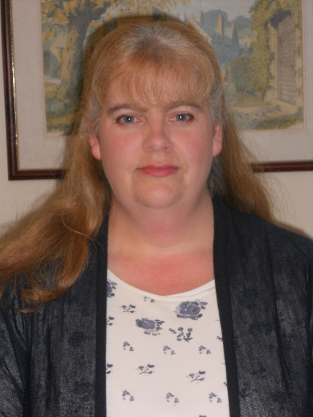
Foundation Governor

I was appointed to the role of foundation governor in September 2015.

I am a Primary Teacher of many years’ experience, having qualified in 1994. My career has included work in both Inner and Greater London, before moving to Torbay with my husband in 2001, when I became a supply teacher, working in several schools in the local area.
I have a long association with Queensway School. Firstly during my teaching work here as both long and short term supply teacher, and secondly in my role as a parent of two boys currently attending the school.
I am a reader at our local parish church of Sacred Heart where my elder son is a regular server. I am also a volunteer for the Catholic charity Marriage Care where I am one of a team of presenters for their Marriage Preparation courses.

During my time as a governor at Queensway I hope to use my own experiences to benefit the school in its continuing work to provide the best possible education and care for all our children. I also hope to learn more about school management and increase my own knowledge of the latest developments in education.

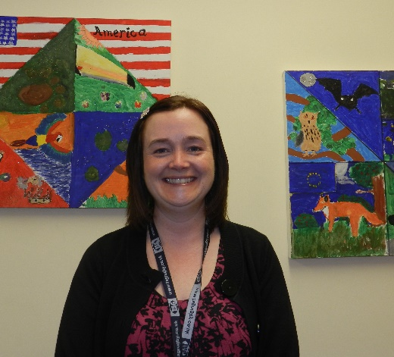
Mrs. Teressa Lewis
Support Staff Governor

In 2009 I relocated to Devon from the West Midlands with my husband and 2 children. Prior to that we spent many happy holidays in and around Torbay and had a dream to eventually be able to make our home in Galmpton.

The last 21 years of my teaching career have flown by. I have spent most of that time teaching in Catholic schools in and around the Birmingham area before starting the Devon phase at Queensway. It has been an honour to be a part of so many children’s lives and to be able to guide and encourage them to achieve their true potential and support them through the difficult times in their lives.

My desire to teach was born through a passion for science and the hope that I could pass on a little of that inspiration and curiosity to others. My own inspiration came from a brilliant physics teacher who once told me “science does not tell you the answers it just teaches you how to ask the questions”. During my time at Queensway I have developed science clubs for children across both key stages where the emphasis is all about discovery and the investigation of what will happen if…

In my spare time I love to read and bake. As a family we spend much of our time walking and camping out on Dartmoor. I am also a keen kayaker but get very nervous as I have an acute phobia of fish.

Mrs. Julie Kennard
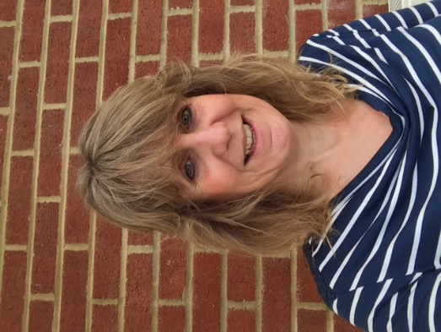
Staff Governor

In 1995 I moved to Torbay from East Anglia. This is an area I love and know well as my Grandparents lived in Livermead for many years. Many happy summers were spent on Hollicombe Beach as a child! Having spent twelve years living in Babbacombe I now live with my two grown-up sons on the fringes of Paignton.
I came to Queensway as a Supply Teacher in 1998 and worked in both Key Stages 1 and 2. In 2000 I was appointed
to cover a Year 2 Class, initially for one term and I have stayed ever since! Ours is a small school where everybody knows one another and from very early on I have always found it a warm, welcoming place where people support one another.
I qualified as a Primary Teacher in 1989 after training at King Alfred’s College in Winchester. I had always wanted to be a teacher and started ‘practising’ on my younger brother when I was about 7 when we played schools together with a variety of toys. My brother used the toys to act out the roles of the naughty pupils (they were always naughty!) and guess who was the teacher?! It always makes me smile when parents tell me at Parent’s Evenings that their child plays schools at home because I know where this can lead!! I love working with young children as they so often see things purely at face value and have no hesitation about telling you what they think! It is such a privilege to be able to be part of so many young people’s lives and to help them develop as individuals.
Originally from Hampshire, I am a keen Southampton F.C supporter and will make the journey over to St. Mary’s with my dad and younger son when possible. It is great to be able to have 3 generations all supporting the same cause- well, I think so!! I love to walk in the countryside or along the coast paths and swim when I can. I enjoy cooking and usually have a supply of pumpkins in my under-stairs cupboard awaiting a new recipe -much to the amusement of the other staff!

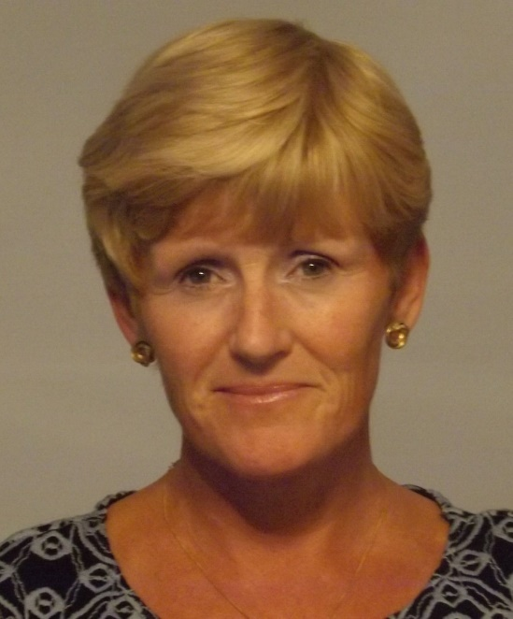
Mrs. Jane Fraser
Head Teacher/ex officio Governor

I am married to my best friend and blessed with two wonderful sons and a beautiful daughter-in-law.
We first moved to Torbay from the North West in 1987. Work then took us away to
Cornwall and Dorset and back to Paignton in 2004.

I have been teaching in the Diocese of Plymouth for 11 years and am very excited and privileged to join the Queensway family as interim Head Teacher.
I too am a Man City supporter so you may see more 'blue' appearing around the school!
I have an open door policy so please don’t hesitate to
come to see me if you have any worries or concerns.

HOW DO WE KEEP YOU INFORMED?

*By information contained within “Queensway News”
*By information on the Governors’ section of the school website
- Minutes of Local Governing Body meetings
- General Information
- Details of Governors
- Photos of Governors

FOUNDATION GOVERNORS

Foundation Governors are appointed by the Diocese. The role of the foundation governor is to ensure that the school is clearly recognisable as Catholic in its ethos and that its role is seen in the provision for Catholic children of the Diocese.

PARENT GOVERNORS

Parents of pupils registered at the school are eligible to stand for election as a parent governor. They are elected by other parents at the school. Queensway Catholic Primary School currently has one elected parent governor.

STAFF GOVERNORS

The Head Teacher is automatically eligible to be a full member of the Local Governing Body by virtue of the office but the Head Teacher can choose not to be a governor. Both teaching and support staff, who are paid to work at the school, are eligible to stand as staff governors. They are elected by their colleagues. Queensway Catholic Primary School currently has 2 staff governors.

WHAT IS THE LOCAL GOVERNING BODY RESPONSIBLE FOR IN THE SCHOOL?

FINANCE AND PREMISES
The three main areas of responsibility are;
- Agree the annual budget.
- Manage and monitor spending throughout the financial year.
- Ensure the provision of safe and suitable premises for the delivery of our children’s education.

PAY AND PERSONNEL
The three main areas of responsibility are;
- Matters to do with staffing;
  - Recruitment
  - Training
  - Deployment
- Pay related matters.
- Staff pastoral care.

STANDARDS AND ATTAINMENT
The five main areas of responsibility are;
- Promote high standards of educational attainment.
- Ensure continued school improvement.
- Review targets for pupil attainment.
- Report on pupils' achievement in National Curriculum assessments.
- Set standards of behaviour.

SPIRITUALITY AND ETHICS
The five main areas of responsibility are;
- Ensure that the Catholic ethos and school statement are living elements in the life of all members of our school community.
- Ensure that the school is fully engaged in the delivery of the R.E. curriculum as specified by the Bishop of Plymouth.
- Ensure that the Catholicity of the school is maintained, supported and promoted.
- Ensure that the admissions policy is adhered to when assessing the annual list sent by the Local Authority.
- Ensure that the admissions policy is adhered to when assessing a casual admission.

MEETINGS

The Local Governing Body has scheduled its first meeting of the academic year for Tuesday 8th September at 4.15 p.m.
There will be three scheduled meetings each term, with others convened as necessary.

The meetings timetable for the year will be agreed at that meeting and displayed on the Governing Body board in the school reception area and on the Governing Body page on the school website.

Mrs. Hilary Morley - Clerk to the Local Governing Body

If you wish to contact the Local Governing Body directly, the clerk is usually in the school office.

The Local Governing Body can be emailed at queenswaygovernors@gmail.com

