English  Year 2  The story of Pirate Tom - fiction  Penguins – non-chronological report  Tiddler - fiction (sea creatures)  Year 1  The boy who cried Ninja - fiction  What happens when? – information text  The first poetry book – poetry  A dog’s day - fiction  Dino Dinners - fiction |  | PSHE  We will be looking at our own safety at the beach and in the sun.  We will continue to develop our social skills with respectful discussion techniques.  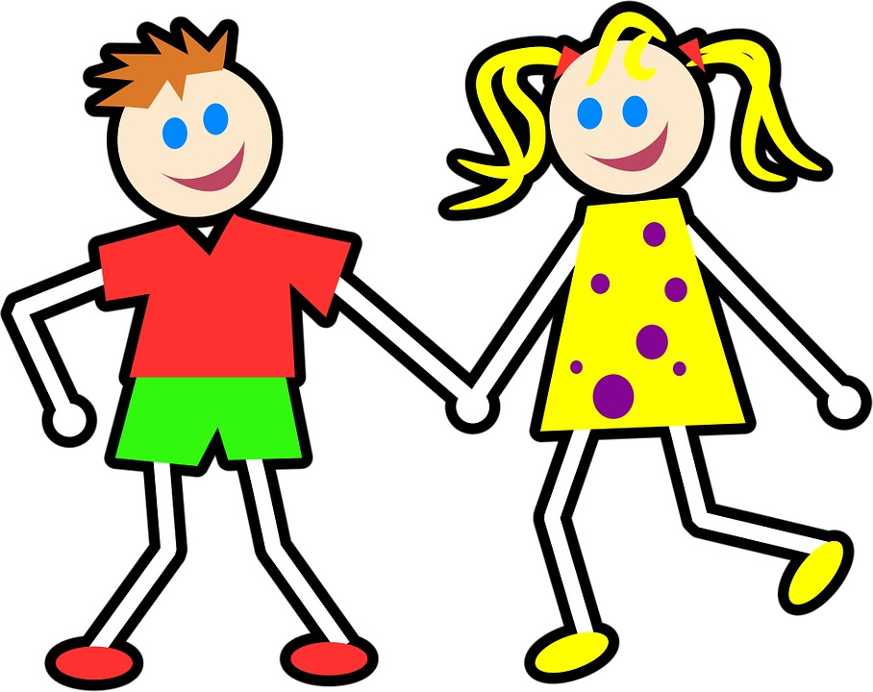 | Geography  We will be spending most of our time exploring the coastal features of our area. We will identify the different features and look at who lives there!  We are planning to visit Goodrington Seashore centre mid July to help us with our investigations.  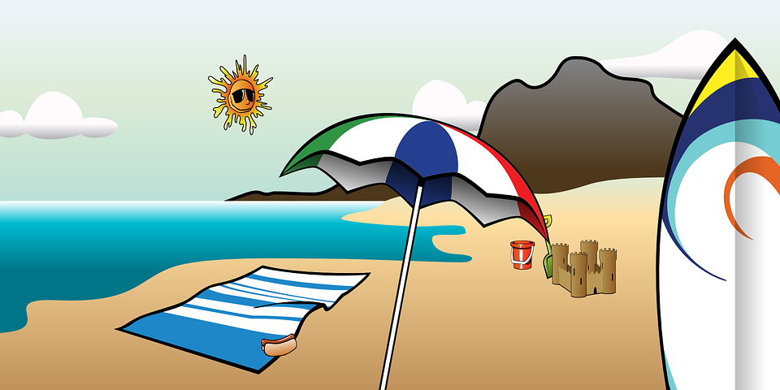
Art / DT  We will be creating a ‘beach in a jar’.  During our school trip to Goodrington we will be designing some shell art and sculpting on the beach.  We will be creating paper mache 3d art work, as well as looking at colleges, and printing. | PE  The children will continue to work with TUFC completing team games and working on multi skills. | Beside the Sea  Year 1/2  Learning Experience  Summer term  Outcome: We will be creating a large class Beach fact file book.  We will have a shared KS1 learning assembly and would love you to join us!  WE NEED 1 GLASS JAR (WITH LID) PER CHILD | Maths  We will begin this term by looking at Multiplicative Reasoning where we will practise and revise all our times tables including 2,3,5,10 times tables. We will look at how we can apply these skills to problems and use our reasoning to explain.  After this we will be exploring Geometric Reasoning where we will revisit fractions, position and shape.
Science  We will be looking at living things and their habitats. We will be focusing our investigations around creatures found at the beach. We will be compiling fact files around those creatures and the individual features of their habitats.  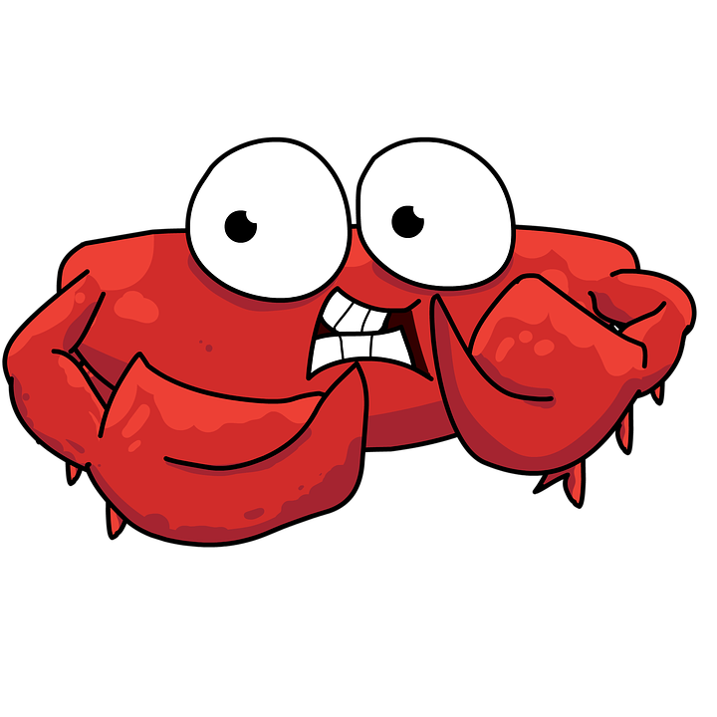 |  |  | RE  Pentecost and mission: we will learn about this very special time in the Bible when the disciples and other Christians received the Holy Spirit.  Judaism, Sikhism and Hinduism: We will explore these different faiths and have respectful discussions about the similarities and difference between these faiths and ours. We will look at their individual festivals and how they celebrate them.

