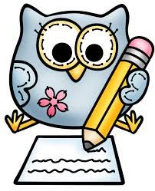
Year 6 Learning Experience Overview: Spring 2
English
The children will be reading a
short story called ‘Art’ by Tony
Ross, which will be the
inspiration for writing our own
ghost stories. We will look at
how to build suspense and tension in our writing.

This will then develop into non-fiction writing about Charles Darwin (linked with our science work on evolution) as they explore the many amazing discoveries he made and work on presenting this in a detailed report.
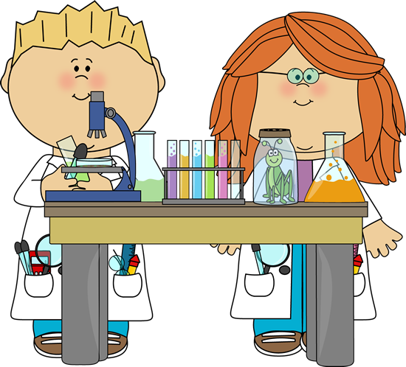
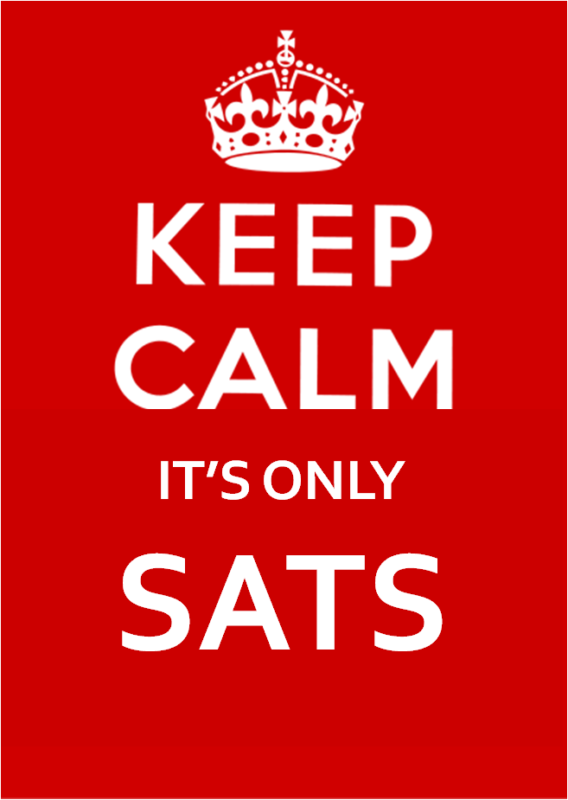
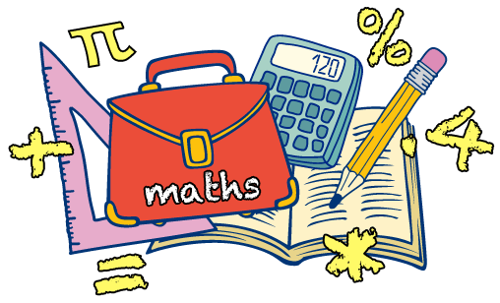


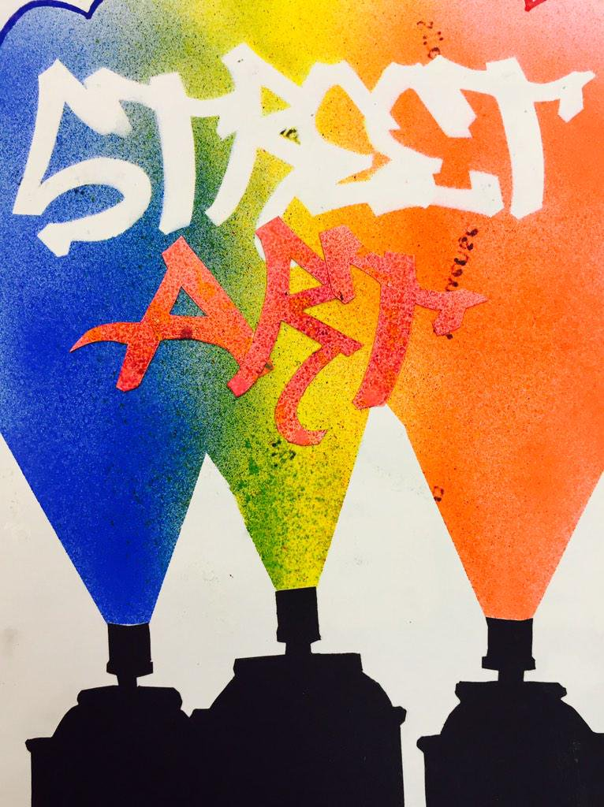
Maths
The children will be
revising written methods
of long multiplication and
securing their understanding
of long division as well as exploring methods we can use to improve mental calculation skills.

We will move on to learn about ratio and scale factors and use this to help us solve problems. Alongside this we will be developing their arithmetic skills and particularly on increasing the speed and accuracy of their calculations!
SAT’s
In preparation for the SAT’s we will be looking at past papers, exploring techniques for ways to successfully tackle the different question types.

This will run alongside the PSHE sessions which will focus on confidence, perseverance and the importance of learning from mistakes.

Science
Evolution... variation...
inheritance...

In this challenging topic the
children will explore how
characteristics are passed from one generation to the next and how species have adapted to suit their environments.

They will go on to discover the process of natural selection, and how our understanding of the process of evolution has developed over time thanks to the work of scientists (such as Darwin) and palaeontologists.
RE
The children will be exploring the topics of ‘Lent’ and ‘Holy Week’ where
they will learn about the events that took place leading up to Easter, particularly the betrayal of Peter in the garden of Gethsemane.
History
In this unit of work, the
children will take a journey
through British history and
discover how crime and
punishment has changed
throughout the ages. Beginning with the Romans and travelling right through to the present day, they will discover how changes in society create changes in the kind of crimes that are committed, as well as the ways in which they are punished.
Art
Find out all about the many
Varied forms of art in public
spaces, and develop their own
ideas for quick, colourful,
eye-catching, humorous or
satirical pieces of street art
through sketching and
annotating.

