
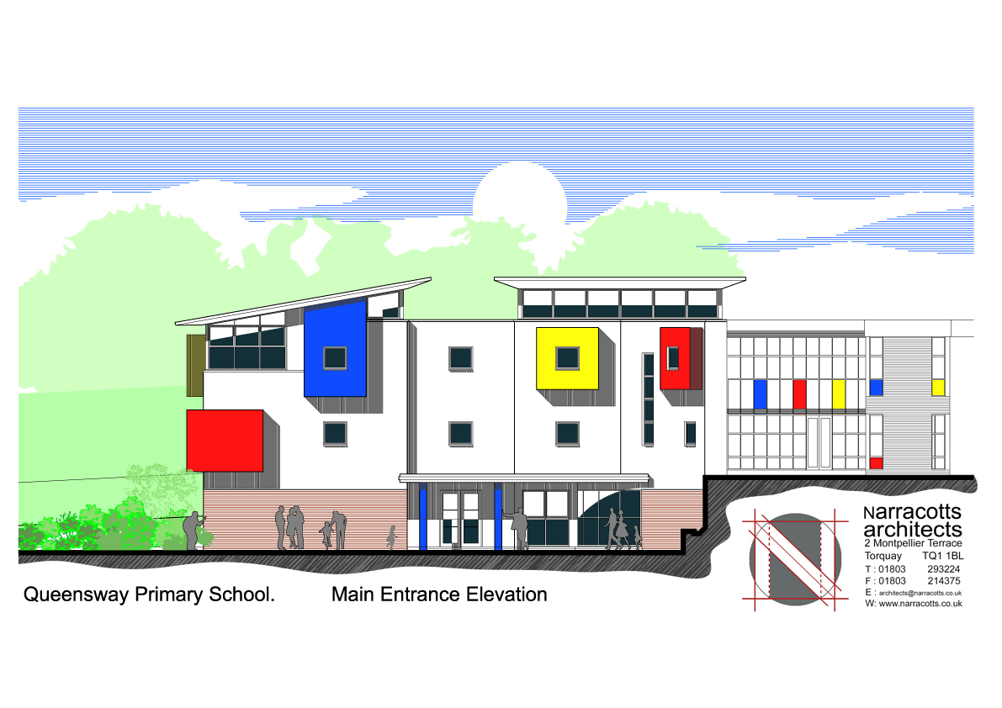

OUR LADY OF THE ANGELS CATHOLIC PRIMARY SCHOOL
QUEENSWAY
CHELSTON
TORQUAY TQ2 6DB

Tel:01803 613095

e-mail admin@queenswayprimary.co.uk

Parents and Carers

I am writing to let you know that a number of children have recently been absent from school with suspected Norovirus, a common infection which causes symptoms of diarrhoea and vomiting.

I would like to reassure you that Norovirus is generally a mild infection and people usually recover fully within 2-3 days. No specific treatment is needed, but it is important to drink plenty of fluids to prevent dehydration.
As you may already know, Norovirus is highly infectious and spreads easily from person to person, especially in close knit communities such as schools, therefore, we are asking for your help to prevent further illness within the school by following the advice in the checklist below:

If your child develops symptoms of diarrhoea and/or vomiting you should keep them off school and away from other childcare settings such as childminders until they have been symptom free for at least 48 hours.
Good hygiene is important to stop the spread of infection, especially hand washing, frequently and thoroughly with soap and water, particularly after using the toilet and before eating.
Good hygiene in the home will also help prevent spread to other family members. If possible separate toilets and towels should be used and door handles, wash basins and toilet handles should be frequently cleaned.
If symptoms do not resolve after 48 hours or if you are concerned please contact your GP by phone or contact the NHS non-emergency number 111.
We would like to thank you for your help with this.
Further information is available on the website:
http://www.nhs.uk/conditions/Norovirus/Pages/Introduction.aspx

Yours sincerely

Mrs Jane Fraser
Head Teacher


“You are like light for the world.” (Matthew 5 v 14)





