Year 4 Homework
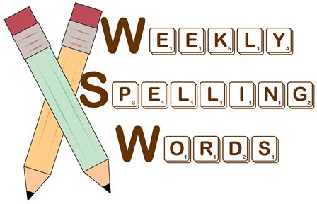

Your child has been provided with a range of activities to help them learn this week’s spellings. They should complete at least two of the activities each week, more if they can - a little and often approach is best. Each Friday they will have a spelling dictation test and then be given a new list of spellings for the following week

All children should know their multiplication tables and corresponding division facts by the end of Y4. Your child will have learnt x3, x4 and x8 in Year 3. This term we will be revising 3,4,8x. Each week your child will need to practise their tables for a maximum of 15 minutes although again a little and often approach is best. All children would also benefit from practising the tables they have already learnt so a weekly practice sheet is included for this as well.

Spelling & times tables homework should be completed and brought into school each Thursday. We would like to encourage your child to develop good study habits. Children who do not complete their homework will therefore be expected to complete the work during their Friday break time.

