DIOCESE OF PLYMOUTH

VICARIATE FOR EVANGELISATION CATECHESIS AND

SCHOOLS

Section 48

INSPECTION REPORT

Queensway Catholic Primary School
Queensway.

Torquay

TQ26DB

URN 140745

Head Teacher: Mrs Jane Fraser

Chair of Governors: Mrs Angela Baldwin

Introduction

The inspection of Queensway was carried out under the requirements of the Education Act 2005, and in accordance with Plymouth Diocesan Framework and Schedule for S48 inspections, approved by the Bishop of Plymouth.

Context for the Inspection

Queensway is an average sized school with 199 pupils on role. Of these 24.6% of children are in receipt of pupil premium and 14.5% of children receive free school meals. 12% of children are on the SEND register and 5% of children have a statement of special educational needs.
18.1% of children have English as an additional language.

Since the last inspection the school has become an academy as part of CAST – a multi-academy trust incorporating all Catholic primary schools within the Diocese.

In 2014 the Head Teacher became ill and subsequently resigned. There followed a period of interim leadership before the current Head was appointed in November 2015.

Key Finding Grade 2: John 13:34-35

‘I give you a new commandment that you love one another. Just as I have loved you, you also must love one another. By this everyone will know that you are my disciples if you love one another’. John 13:34-35

The greatest of all commandments is that we love one another. Living the Christian life is to live a life of love which ultimately leads to washing one another’s feet. This is a journey. There are times when we succeed and there are times when we become distracted. Other priorities take over or we fall susceptible to the secular world which may be offering a different set of priorities or values. Fear, anxiety or a lack of confidence can impact on the capacity of those in leadership to fully respond to the Christian call above all other demands. As a result, although most of the time the community is responding to the call to love, there are times when this can be forgotten and anomalies creep in.

Over the past eighteen months Queensway has been through a period of uncertainty following the sudden retirement of the Head Teacher and a recognition that other members of the SLT had not been enabled to perform in their roles or gain the necessary skills to lead effectively. Despite this the two Key Stage Leaders worked hard to ‘learn the ropes’ and hold the school with the support of a local Catholic Head Teacher in a consultancy role. The strength and commitment of the staff and governors ensured that the school continued to move forward. Gaps in how things were done were recognised but a tremendous effort by all staff ensured that children did not suffer and the school overcame this period of instability. With the appointment of a permanent Head, the school now has a clear focus and desire to move forward.

2

The school has many strengths. In particular Queensway is deeply committed to working with the most challenging of children and supporting them to be the best that they can be. The school has a significant number of children who are not officially recognised as having special needs but nonetheless come from areas in the community where deprivation is high. In addition, the school has three times the national average for children with Education, Health and Care plans. The integration of all these children as well as those with English as an additional language, is key to the success of this school. The school’s mission statement emphasises that it is a ‘place of mercy, freely given, where everyone can feel welcomed, loved, forgiven and encouraged to live the good life of the Gospel’. Throughout the school there is much evidence to show that this is how the community lives this out. In this respect it is a school which daily seeks to serve one another. The dignity of every person is a priority and reflected in the way everyone respects one another and in particular the most vulnerable. In real terms every child is seen as unique, special and loved by God.

The religious life of the school is growing and although there are some areas for development in terms of overtly showing this, implicitly the attitudes of the adults in the school reflect Gospel values. There is a strong sense of witnessing to one another and a desire to grow in all that it means to be a Catholic School. The liturgical life of the school is also beginning to develop and in some areas provides children with opportunities for deepening their relationship with God.

The teaching of RE is given due prominence and is seen as an integral part of the curriculum. Teachers are keen to provide children with well-planned lessons and activities which will engage and motivate them.

SUMMARY OF KEY FINDINGS

Care and concern for every child at Queensway so that each one can learn and grow to the best of their ability lies at the heart of the mission of the school.

Queensway is a positive school where children enjoy coming to school. Most of the children behave well and respond well to expectations and boundaries.

Adults provide children with a safe and consistently nurturing environment, rooted in a desire to serve and not to count the cost.

The school recognises the need to be overt in displaying its identity as a Catholic School and are beginning to set in motion a plan to bring this about.

The worship life of the school is currently being developed. Appropriate CPD in this area could help teachers to feel more confident in enabling children to deepen their prayer life without it becoming a teaching opportunity.

Teachers are growing in confidence with the teaching of RE and with appropriate support this could become an area of strength.

3

Areas of Focus for Development

The school’s mission as a Catholic School would be further enhanced by focusing planned development in the following areas.

The development of a more overtly Catholic identity around the school.

To create a five-year plan for working with the SCC document so that it becomes embedded in the life of the school.

Queensway as a Catholic Community | (Welcome, Welfare, and Witness)
Grade 2 | John 13:34-35

Rooted in the Gospel are, amongst others, three particular dimensions which determine the quality of our Catholic life; the capacity for welcome, welfare and witness. At Queensway there is a genuine commitment to understanding what these mean and allowing them to permeate every aspect of the school’s way of life. The school is succeeding in many ways.

The arrival of the new Head Teacher has already had an impact in small things such as the availability of senior leaders for parents on the gate at the beginning and end of each day. This has been welcomed by many and their appreciation is evident in the parent surveys. This is a more overt dimension of the quality of welcome that already exists in the school, specifically in the adult relationships which are supportive and open. All children are welcome and much is done to ensure that all children feel at home and supported, regardless of need. The school is slow to judge and reflective in its actions and words. With a significant number of children, who demonstrate challenging behaviour, it is important that adults are consistent in their response to this. Throughout the inspection this was evident to see. Some staff are Thrive trained and most staff have had some access to the philosophy and approach of Thrive. As a result, adults are supported to respond in the best way possible. Their openness to one another allows them to seek help and advice confidently without fear of judgement.

In the wider community the school has an excellent reputation for the way in which it works with children who have special educational needs. It is recommended by the Local Authority to parents for the work and care it offers to children who need specialist help. In addition, the school’s relationship with parents and carers is improving and surveys make it clear that there is a positive feel about how school communications have improved significantly.

Since the beginning of the academic year the school has introduced into its mission statement the theme of mercy. The desire to be a school based on faith, hope and love, is at the heart of decision making and seeking the best for every child. Despite falling numbers of Catholic children the desire to witness to God’s message is having an impact on how the different groups within the community live and work together. This includes the children taking on specific roles of responsibility which they do with pride, demonstrating their own appreciation of what it means to live the Gospel. It is in the small, but consistent actions, such as year 6 children bringing reception children to liturgies and sitting with them, that this is most evident.

4

In addition, charity work by the children is very important to them. They regularly seek to raise money for causes that mean something to them as well as supporting on an annual basis, CAFOD, Children in Need and Missio.

The school has positive links with the parish and a growing desire to strengthen these and engage more fully with them. Given the distance from the school to the church this will be challenging but a creative response to this could bring about a very fruitful engagement and enable the children to have an enriching experience. In addition to the parish the school has efficient communication methods to ensure that as far as possible everyone who needs to be is kept informed of events, news and anything else that needs to be communicated.

The school is developing solid partnerships with other schools within CAST and makes a positive contribution to this through their attendance at INSET and other Diocesan events. Members of the teaching staff are key to initiatives outside of the school such as the RE curriculum writing group and contribute widely to local school cluster meetings for shared planning.

Focus areas for Development

- Ensure that the pupils’ involvement in the school and their interaction with the wider community is developed so that they have a stronger sense of their own voice and capacity to contribute to decision making within the school.

- Deepen a sense and understanding of Gospel values so that everyone is able to articulate what this means and respond to questions about what makes Queensway different and special.

The School as a Catholic Community | Leadership and Management
Grade 2 | John 13:34-35

After a period of instability, Queensway now has a leadership team which has the capacity to grow and develop. The recently appointed Head has significant experience as a Deputy Head and prior to her appointment at Queensway had been supporting another CAST school. Enabling the other members of the senior leadership to develop their skills will be an asset to the school. They are committed people with a desire to serve the school to enable it to become the best it can be.

The atmosphere in the school is very positive. It is clear that all members of the school community feel valued by those in leadership and respond well to new initiatives. Monitoring activities relating to teaching, learning, spiritual and moral development are becoming more focused. These are identifying areas for development and implementing. Opportunities for CPD are being taken up resulting in three members of staff participating in Successful Teaching and Learning courses and others obtaining coaching and mentoring in a variety of areas including EYFS, Autism, safeguarding and RE amongst others.

5

The school has an established Governing Body that has the capacity to meets the school’s needs and move it forward. Governors can talk confidently about their role and are able to evaluate how the school is progressing. As experienced governors they have the capacity to challenge appropriately and supportively. Governors regularly visit the school and because of the role the Chair of Governors has in the nursery which is attached to the school, there is regular communication with the school.

Focus for Development

- To ensure that the new leadership team becomes embedded and to further develop systems in the school for middle leaders to grow and feel confident in their roles.

- For the RE leader to be given the opportunity and time to work more closely with other local leaders to develop confidence and gain support to lead effectively.

- To develop the role of the RE link governor so that all governors can have a clear insight into how RE is developing within the school.

The School as a Teaching and learning Community | Word
Grade 2 | John 13:34-35

Throughout Queensway, teachers model Christ is their approach to teaching. Relationships are positive and children feel safe and well cared for. Compassion, understanding and gentleness ensure that children are able to engage with the teachers and respond positively to their learning. Due to the challenges that some children experience, there are occasions when some are distracted and find it difficult to remain focused. TAs are deployed in such a way that they are able to pick up on most children who need attention and support. They do this without drawing attention to themselves and with gentle persuasion are generally able to keep children on task.

Seven lessons were observed over the two days. In most lessons children responded well to the input and activities provided for them. They frequently demonstrated good recall and sound knowledge. Teachers ensured that lessons were for the most part challenging and engaging. A combination of teacher input, pair conversations and group work enabled most children to progress. In some lessons the activities or approach to the material made it difficult for children to respond to what was being asked of them. At other times the learning objective could not easily be achieved because appropriate building blocks were not put in place. Although teachers plan thoroughly some work is required to ensure that the aim of lessons is understood and activities make it possible for all children to achieve at an appropriate level. Teachers appear to be growing in confidence about how to use levels in RE and offer a balance of activities between AT1 (Learning about Religion) and AT2 (Learning from Religion). Marking in books is strong and demonstrated the quality of learning that takes place in lessons and opportunities for children to take their next steps.

6

Children speak positively about their lessons and enjoy RE. They believe that they learn a lot about Scripture and believe that the work they do helps them to see the importance of RE in their lives. The general behaviour of the children, their respect for one another and care for the wider community suggests that their learning is having an impact on how they are growing into responsible citizens.

The RE Leader, for a variety of very good reasons, has been unable to move RE forward as far as she would have liked. However, she has been very successful in motivating teachers and encouraging them in their planning. Her resilient approach and desire to support is to be commended.

Areas of Focus for Development

- To develop a systematic approach to monitoring – in particular looking at how teaching meets the needs of different groups of children.

- To ensure that lessons are suitably planned so that pupils remain engaged, apply themselves diligently and can work at a good pace.

- For teachers to continue to develop skills in assessment for learning so that children are challenged and can make progress.

The School as a Celebrating Community | Worship
Grade 3 | John 5:6-8

Whilst Queensway is a school with a strong and meaningful commitment to its Catholic life, its worship and prayer life is currently limited in what it offers to the children and adult community. This is not because people do not care but primarily because there is a lack of understanding, knowledge and skills to be able to deliver creative and consistently prayerful opportunities for children to deepen their natural spiritual selves.

One of the reasons why the school has become ‘stuck’ is that it has not had been enabled to move forward. There are clear signs that under the new leadership there is a desire to change this and small steps have been taken to address the issue. At present ‘Acts of Worship’ in classrooms tend to be wordy and an extension of teaching, rather than a time of reflection and prayer. As a consequence, children do not always find it easy to be reflective, to sit in silence or be still. Whole School ‘Acts of Worship’ are beginning to take on a liturgical feel but again this is an area where all staff need the opportunity to develop and then children also.

The school has a positive relationship with the two churches which make up the parish and currently children attend Mass on a rota basis in the parish as part of their class group. This is a Parish Mass and as yet the role the children play in this is minimal, though there is a desire for this to be developed and plans are in place for this to happen. Within school children are involved when the whole school gathers for Mass.

7

Focal points in classrooms are a strong feature, child-focused and often forming a part of the teaching and learning that takes place. They are both engaging and a delight to experience. In some classes it is clear that children contribute to these and they are used as part of classroom prayer.

Given the willingness of the staff and the general ethos of the school there is no doubt that the school has the capacity to move forward in this area, with appropriate support and formation. In particular, it would be a positive step for staff to experience the prayer life of other schools to appreciate the gaps and begin to bridge them within Queensway.

Focus for Development

- To develop a wider range of experiences for the children to grow spiritually including for example: meditation, spontaneous prayer, voluntary prayer.

- To continue to develop acts of worship which are liturgically shaped and involve children taking greater leadership.

- To support staff to create and develop class acts of worship which are rooted in prayer rather than teaching orientated.

Conclusion

Despite the struggle that the school has had over the past eighteen months, it has maintained a very positive focus. In particular, the total commitment of the adults to the children and in particular many vulnerable children, is to be commended. It demonstrates, and the Bishop can be confident of this, that Christ lives at the heart of this school. As a result it can only go from strength to strength.

Sarah Adams

March 2016

8

THE SCHOOL AS A CATHOLIC COMMUNITY
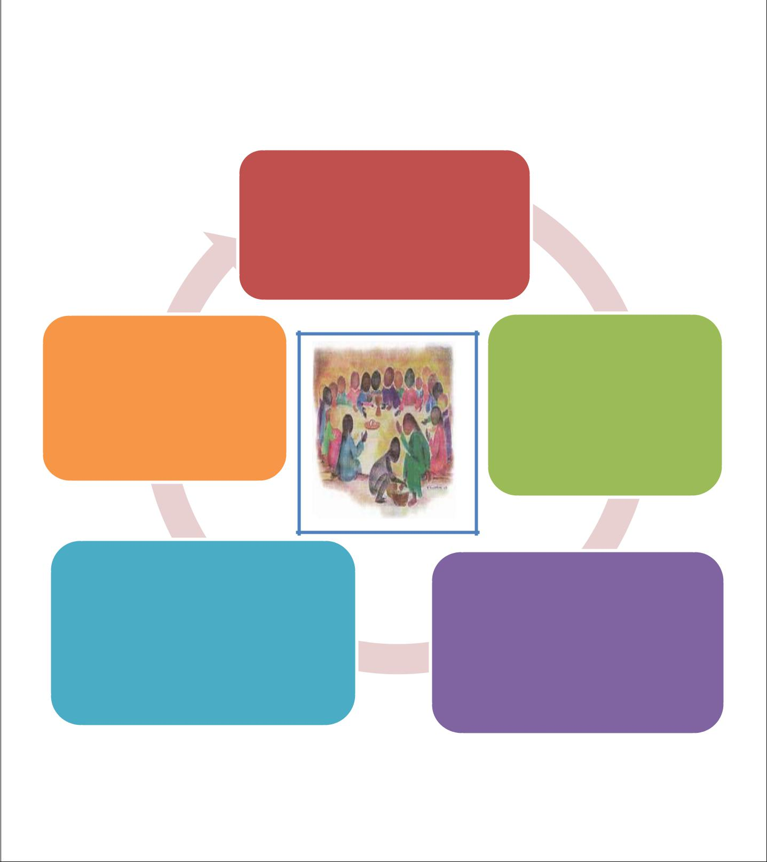

WELCOME
Koinonia
The School as a Catholic
Communiy
WORD | WORSHIP
kerygma | leiturgia
The School as a | The School as a
Teaching and
 | Celebrating
Learning Community
 | Community
WITNESS | WELFARE
marturia
 | diakonia
The School as an
 | The School as a Caring
Evangelising Community
 | Community
Introduction

The Catholic community is one that is rooted in Baptism, Eucharist and an on-going call to Conversion. The areas of Welcome, Worship, Word, Welfare and Witness can be described as the key components of what it means to live the Christian life. As such, the school as a

9
Catholic community, is called to embrace these as a way of being community and living the mission of the Church. The manner in which these are expressed reveal for us the heart of where the community lies.

Koinonia - (κοινωνία) Welcome

Koinonia is the Greek work for communion, for participation, for the sharing with one another. It is to be welcome an ‘other’ in fellowship and love. It is to be of an open disposition to receive from another and to respond in love. Within the community it can be minimalized to the gesture of greeting at the front entrance. In school it might simply be seen as the role of the receptionist. Koinonia however, requires a much greater vision of what it means to welcome. Ultimately it speaks of the disposition of every member of the community to be open to the needs of another, be that to listen, to hear, to respond, to act. The idea of welcome will be embedded in all aspects of the school’s way of doing things.

Leiturgia – (λειτ-ουργία) Worship

The Greek word ‘leiturgia’ means public activity or in a religious sense it means ‘respect’ or ‘service’. When it was adopted by the Church it meant to carry out a religious service. It is a public service as opposed to private prayer and concerns the Christian community gathering first and foremost to celebrate the paschal mystery of Jesus Christ. It is also a time when the community gathers to be reconciled, to celebrate, to be fed, and to be sent out in mission. Central to the Catholic School is its call to be a Eucharistic community in the widest sense – that is to be the body of Christ ready to serve the world in its fullness. All prayer, all liturgy ultimately is intended to lead to this. It is not something that happens once a week and has no further meaning. It is an invitation to live each day what has been received through Word and Eucharist.

Marturia – (μαρτυρια) Witness

The core meaning of the Greek word marturia means to testify, to give witness, from which we get the word martyr. Simply it means to share our values and faith with the world and our local community so that others may come to know the love of Christ. Within the Catholic School community this will mean promoting a shared vision and shared values which stem from a shared sense of the teaching of the Gospel. The Christian is called to witness to

Christ’s teaching in the way they live their life. Like John the Baptist these values are those which direct others to Christ.

Diakonia - (διακονία) Welfare

The word ‘diakonia’ comes from the Greek word to mean to serve the poor and the oppressed. The emphasis within the word is on service and care for others. Within the Christian community diakonia is a way of being with others. It encourages care and concern for every person regardless of who they are or where they come from. Within the Catholic school, service lies at the heart of the community. It is about how children are supported in their learning, shown compassion when their behaviour is challenging and cared for when they are unhappy or in need. Equally it is about how adults are cared for and care for one

10

another. At the same time the community is one that reaches out to the local community and the wider world, recognising the needs of others and responding to these generously.

Kerygma – (κήρυγμα) Word

Kerygma is the New Testament Greek word for preaching or proclaiming the message of Christ. Within the context of the school this is expressed both in how we expose young people to the person of Christ as revealed in scripture, and the manner in which we teach. Access to the WORD of God through scripture and Christian tradition is considered to be a significant part of what the Christian community is about. By the way they are taught children come to know that God speaks to us in the way that we experience and engage with kindness, beauty, justice, the wonders of the natural world, relationships and the needs of others. It is therefore seen as important that in every subject, every lesson, positive values and attitudes are communicated. A confident and open attitude to teaching of lessons well thought about and prepared is central to achieving this.

Self-Review

There will be three key areas within which these five elements will be reviewed:

- The School as a Catholic Community (Welcome, Witness and Welfare)
- The School as a Teaching and Learning Community (Word)

- The School as a Celebrating Community (Worship)

For each of these sections focus areas for evaluation are offered and means of gathering evidence to support this work. See appendix for further guidance.

Scripture Passages

Scripture passages have been selected to highlight where the focus for the community may be at any one time. These will act as a guideline for the self-review process when schools consider the health of its community. The approach to these is best considered within the context of a cycle. Any anyone time the school may find different areas of its life at different points on the cycle:

11

John 13:14-15

Matthew | The School | John
 | as a Catholic
6:24 |  | 13:34-35
 | Commuinity

John 5:6-
8

CONTEXT FOR THE CHOICE OF SPECIFIC SCRIPTURE REFERENCES –

Scripture has throughout history been interpreted in a variety of ways and is constantly being reinterpreted. The interpretations given here are one way of looking at how the passages may be understood within our own context. Equally there are many other passages which may have been selected but for now these reflect what is at the heart of our mission and seem appropriate.

Grade 1: ‘If I, your Lord and Teacher have washed your feet, you are also to wash one another’s feet. For I have set you an example, that you should also do as I have done to
you’. John 13 14-15

The night before he died Jesus washed the feet of his disciples. Peter, one of the disciples was affronted. To wash another’s feet was the lowest job of all, one done by the servants.

Jesus, as the leader of the community he was about to establish, was very clear. The call to Christian ministry is a call to service, a humbling act of giving to one another. Unless we can serve our brothers and sisters we can have no part of in the life of Christ. A secular

12

John 5:6-8’
understanding of leadership often results in a top down mentality and little shared responsibility. The Christian community however, is one where those in authority act out of their desire to serve, not to be served. As a consequence the message of serving one another permeates the whole community.

Grade 2: ‘I give you a new commandment that you love one another. Just as I have loved you, you also must love one another. By this everyone will know that you are my disciples if you love one another’. John 13:34-35

The greatest of all commandments is that we love one another. Living the Christian life is to live a life of love which ultimately leads to washing one another’s feet. This is a journey.

There are times when we succeed and there are times when we become distracted. Other priorities take over or we fall susceptible to the secular world which may be offering a different set of priorities or values. Fear, anxiety or a lack of confidence can impact on the capacity of those in leadership to fully respond to the Christian call above all other demands. As a result, although most of the time the community is responding to the call to love, there are times when this gets forgotten and anomalies creep in.

Grade: 3 ‘Do you want to be made well? The sick man answered him, ‘Sir, I have no one to put me into the pool when the water is stirred up; and while I am making my way someone else

steps down ahead of me.’ Jesus said to him, ‘Stand up, take your mat and walk.’

The sick man lying by the pool of Bethsaida has been there for a many years, stuck in the one place. Although he wants to be better he appears not to be able to move without some help. Jesus offers this to him and orders him to get up and walk. It could be said that the sick man has resided for too long in a ‘blame someone else way of being’. Sometimes leaders and school communities do become ‘stuck’. Leaders blame teachers, teachers blame students or leaders and the culture prevents an honest engagement in what needs to be done for any progress to be made. Schools stuck or struggling in this kind of cycle need help and support to break free. Healing and reconciliation may need to be a part of this journey. Honest clarification of priorities and challenging self-searching needs to take place for change to occur.

Grade 4 ‘No one can serve two masters; for a slave will either hate the one and love the other, or be devoted to the one and despise the other. Matthew 6:24

Throughout Scripture we are taught that we must choose between God and false gods. Jesus wants us to be free, not just of concerns but of all worries, in order to serve God. It is easy when we are under extreme pressure to respond in ways which are detrimental to our core beliefs and vision. Sometimes this happens because we are facing understandable difficulties. At other times we are insufficiently discerning and go with what seems to be more attractive or safe. Schools can fall into this trap when results and progress become more important than the all-round development of the child. When this is the case the school has lost sight of its meaning and purpose. As a consequence children are being failed and adults not supported to do what is right. Only a radical re-evaluation of what it means to be a Catholic community and a Catholic school will lead to a rediscovery of the commandment: ‘Love one another’ and ultimately to people washing one another’s feet.
13

14

