**English**

We start the year with a story writing unit called ‘The Tear Thief’. The children will use poetic language features to write their own version of the story.We will then then move on to some non-fiction writing using ‘Ripley’s Believe it or not! Mighty Machines’ as our text to write chronological reports. After half term we will continue with another descriptive writing unit and some poetry.

Geography

For our theme this term the children will find out about mountain habitats. They will discover how they are formed, where different mountain ranges are located, what mountain climates are like and the effect of tourism on these habitats. We will move on to compare two contrasting localities looking at similarities and differences.

Outcome

During the second half of term the children will have a whole week of explosive afternoon fun with the year 6 class! We will be making volcanic mountains with papier-mâché before exploding them by making ‘lava’ from bicarbonate of soda and vinegar.

**We are explorers!**

French

In French we will be revising numbers to 20 and colours before moving on looking at names of places and describing a journey to school.

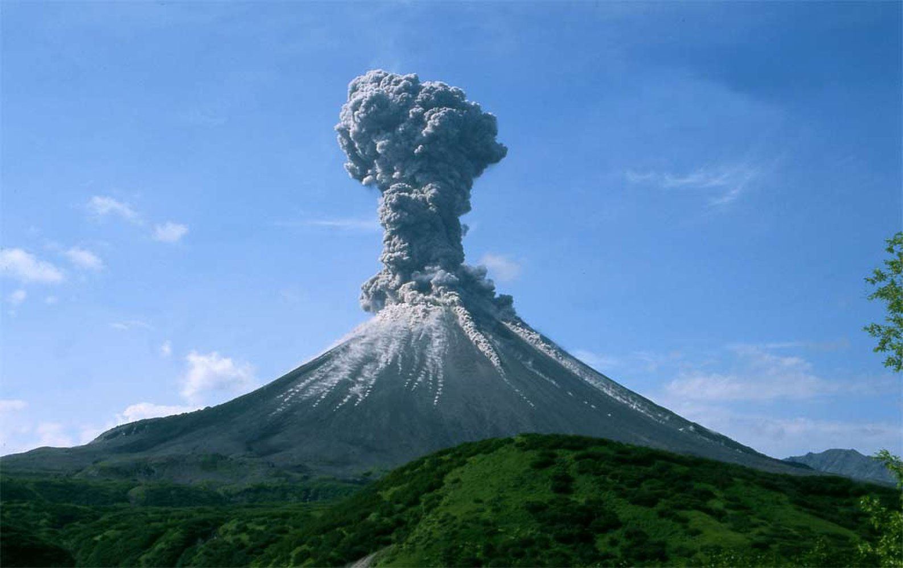

Maths

We start the year by revising the place value of numbers up to 1000 000 including reading, writing, rounding and ordering them. We will then move on to addition and subtraction, followed by multiplication and division later in the term. We will also have a big focus on learning times tables.

Computing

We will be learning about how to use the internet safely and how to efficiently search for information using search engines and different websites.

**Science**

In the first half term we will investigate the effect of different forces on the world around us. The children will learn about the force of gravity and conduct investigations about air resistance, water resistance and friction. After half term we will be exploring space!

Art and DT

Children will investigate the mountain art work of Albert Beirstadt and Nicholas Roerich and try to create their own pictures in a similar style.

In DT we will work alongside year 6 to create some explosive mountains from papier-mâché.

**PE**

The children will play a variety of invasion games and develop their team skills.

Music

The children will continue with their ukulele lessons.

RE

The RE topics we will cover this term are Creation, Prayers, saints and feasts, Sacraments, Advent and Christmas.

PSHE

We will start with focussing on citizenship and move onto anti-bullying and remembrance later in the term.