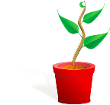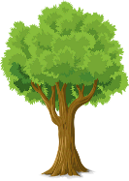

**PARTS OF A PLANT**

**FLOWERS**

**The flowers are often brightly coloured and smell to attract insects. Insects help with the plants reproduction through pollination.**

**LEAVES**

The **leaves** use light from the sun, along with carbon dioxide from the air and water to make food for the plant. This process is called photosynthesis.

**STEM / TRUNK**

The **stem** carries water and nutrients to different parts of the plant. They keep the plant upright.

**ROOTS**

The **roots** of a plant take up water and nutrients from the soil. The roots also keep the plant steady and upright in the soil; they "anchor" the plant.

**What does a plant need to grow?**

Plants

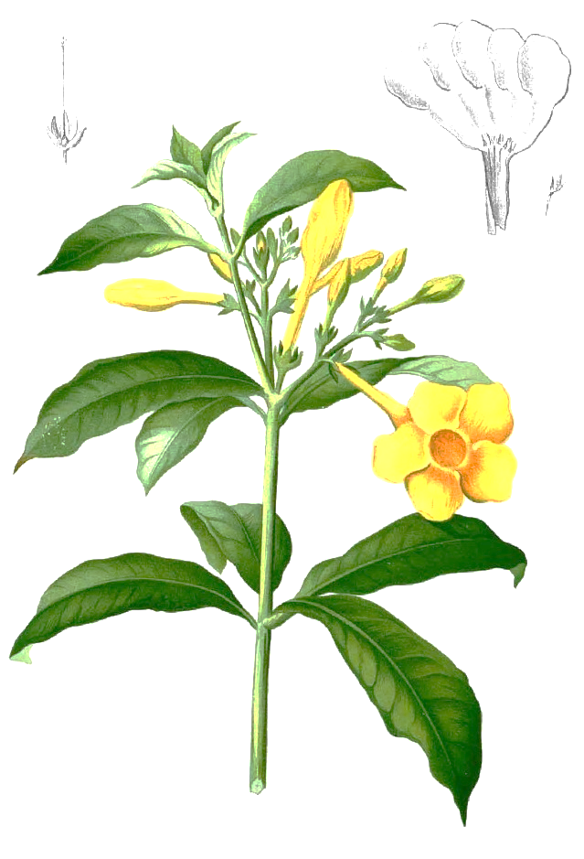

Smaller plants find it hard to survive when larger plants take up space. They block out sunlight and take nutrients and water from the soil.

light

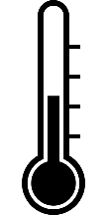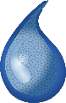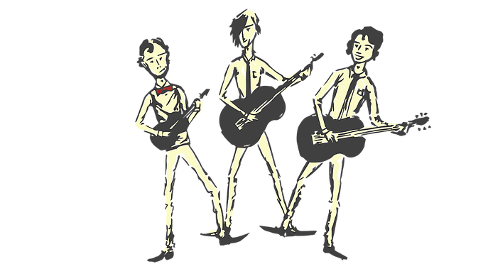

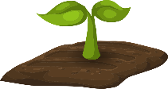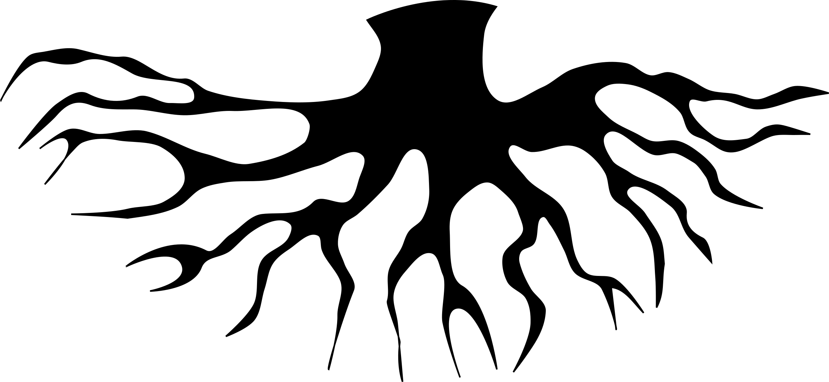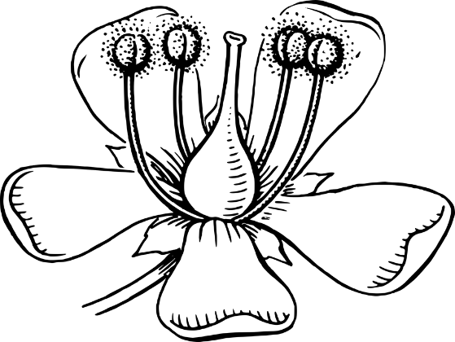

filament

stigma

anther

**PARTS OF A FLOWER**

nutrients

water

warmth

stem

leaves

flowers

Not all plants produce flowers. These non-flowering plants, such as Ferns and mosses. They grow from spores instead of seeds. Non-flowering plants as well as flowering plants make their own food through photosynthesis.

**PLANT REPRODUCTION**

**Pollination -** Pollen is carried by insects or blown by the wind from one flower to another. This process is called **pollination**.

**Fertilisation -** Pollen reaches the carpel of the new flower. Pollen then travels to the ovary where it fertilises egg cells (ovules) to make seeds. This process is called **fertilisation**.

**Seed Dispersal -** The seeds are scattered by animals or the wind. This process is called **dispersal**. Some of the seeds will grow into new plants.

air

roots

style

ovary

sepal

stem

petal