English  The Magic Porridge Pot  We will read the story together, map it out and create actions to help us internalise the story. We are going to create our own stories about a magical item, with a clear beginning, middle and end.  Reptiles  We will be looking at this non-fiction text and identifying its key features. We will then have a go at writing our own non-fiction texts.  Oi Frog!  We will learn the story and investigate rhyming words. We will create our own rhyming poems, using humour to engage the reader. |  | BEAN TO BAR  CHOCOLATE  Year 1  Learning Experience  Spring  Hook: Friday 11th January.  Charlie and the Chocolate factory day. The children can come n dressed as a character from the film and we will be taking part in lots of chocolate related activities.  Outcome: We will be writing to Cadburys to try with designs for a new chocolate box. Hopefully they will like our designs and make them! | Maths  We will begin this term by looking at Number Sense. We will be continuing to count, read and write numbers to 100, and developing our understanding of place value. We will focus on counting in twos and tens and recognising the different denominations of coins and notes.  After this we will be exploring Multiplicative Reasoning where we will have a focus on multiplication and division by two and ten. We will be learning to use pictorial representations and arrays.  Following on from this we will be focusing on Number Sense. We will be looking at number patterns, such as odd and even. We will also be learning how to measure and record using standard units of measurement.  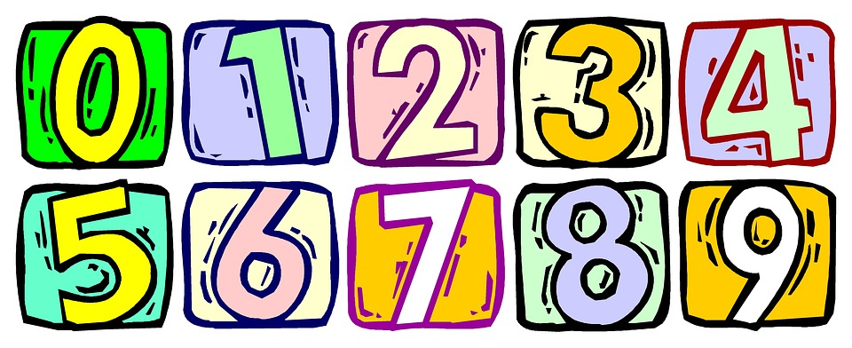 |  | Science  Plants  We will be identifying a variety of common wild and garden plants, including trees. We will also be learning about the basic structure of flowering plants, as well as trees.  Seasonal Changes  We will be observing the changes across the four seasons and describing the weather associated with each season. We will also be looking at how the day length varies.
Computing  We hope to create and debug simple computer programmes, using programmes such as ‘Scratch’. | PE  The children will continue to take part in multi-skills activities on a Wednesday afternoon. |  | ART /DESIGN TECHNOLOGY  We will be designing our own chocolate boxes and putting together a traditional style advert to send to Cadbury’s. You never know they might even make them!!  We will be baking with chocolate (Rice Krispie cakes).
Geography  We will be plotting the journey of chocolate from the bean to the bar. We will investigate where chocolate comes from and the journey it goes through before it reaches our stores and tummies!  We will compare temperatures and customs in other countries and compare them to our own. Focusing our research on Ghana (where chocolate is grown) and the UK.  As well as our thematic related Geographical learning, we also plan to learn to name and locate the world’s 7 continents and 5 oceans, name, locate and identify characteristics of the 4 countries and capital cities of the United Kingdom and its surrounding seas, use simple compass directions (North, South, East and West) and locational and directional language to describe the location of features and routes on a map and use simple fieldwork and observational skills to study the geography of their school and its grounds and the key human and physical features of its surrounding environment. |  |  | RE  Christmas: We will be exploring the deeper meaning of christmas. Considering how different people will have felt about Jesus’ birth. Including: Mary, Joseph, The Wise Men, King Herod. We will look at it from varying perspectives.  Revelation: This unit helps children to become aware of the events in scripture and shows children how special Jesus is to us. The miracle stories unveil the specialness of Jesus and the Kingdom of God. We will explore how Jesus uses this specialness for the benefit of others.  Lent: This unit reinforces the understanding of Lent as being preparation for Easter, commencing with Ash Wednesday and being a time of making space in our lives for God, by seeking forgiveness and doing penance. |  | PSHE  We will be discussing our own likes and dislikes and how we can share these appropriately. We will be introduced to 7 learning behaviours through our Achievosaurus dinosaurs.  